**Supermarket Sales**

Introduction:

Dataset Overview:

Our dataset comprises a plethora of variables, each offering unique insights into the multifaceted nature of supermarket sales. From fundamental transactional details such as Invoice ID, Date, Time, and Payment Method to more nuanced factors like Branch Location, Customer Type, Gender Demographics, Product Line, and Product Ratings, every facet has been meticulously documented.

Key Attributes:

1. Invoice ID: A unique identifier for each sales transaction, facilitating traceability and analysis.
2. Branch (A, B, C): The geographical location of the supermarket branch, allowing for regional comparisons and trend identification.
3. Customer Type (Normal, Member): Distinguishing between regular customers and members, offering insight into loyalty and engagement levels.
4. Gender (Male, Female): Demographic segmentation aiding in understanding purchasing preferences and patterns.
5. Product Line (Fashion Accessories, Electronic Accessories, Food and Beverages, Health and Beauty, Home and Lifestyle, Sports and Travel): Categorization of products facilitating analysis of sales trends across different product categories.
6. Unit Price, Quantity, Tax (5%): Fundamental transactional details crucial for revenue assessment and pricing strategies.
7. Payment Method (Credit Card, Cash, E-wallet): Reflecting evolving payment preferences and trends in consumer behavior.
8. Gross Margin Percentage, Gross Income, COGS: Performance metrics illuminating profitability and operational efficiency.
9. Rating (1 to 10): Customer feedback providing a qualitative assessment of product satisfaction and service quality.
10. City (Yangon, Mandalay, Naypyitaw): Regional segmentation enabling geographical analysis and market segmentation.

Questionnaire:

Q1. Which of the given cities having tax 5% slab performed better than all the others?

Q2. Which customer gender ordered most items from all the three branches?

Q3. Compare highest and lowest rating products on the basis of units sold.

Q4. Analyzing units sold and unit price data answer the following sub questions

1. What is the degree of freedom?
2. Co-relation of Unit price and revenue generated
3. What result you can draw from regression of the two data

Q5. What product will you suggest as per the city data analysis to each type of customer

**Q1.** Which of the given cities having tax 5% slab performed better than all the others?

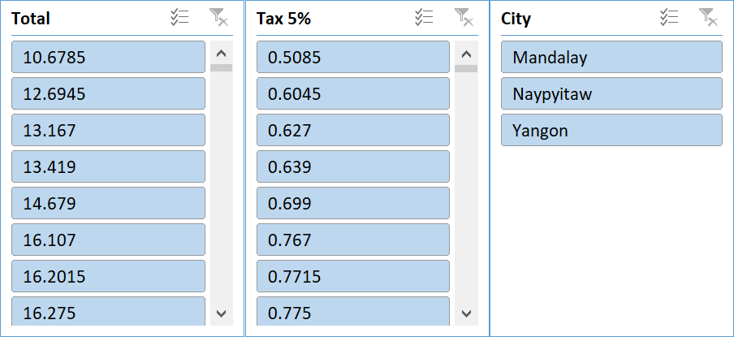

Based on the data analyzed, the city that outperformed all is **Mandalay**. This conclusion is drawn from superior performance in total sales/revenue generation compared to the other cities in the same tax slab of 5%.

**Q2.** Which customer gender ordered most items from all the three branches?

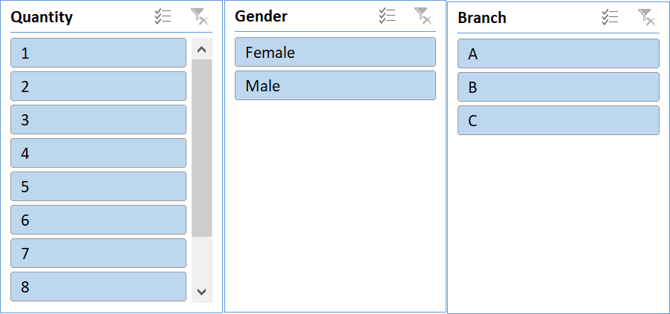

**Q3.** Compare highest and lowest rating products on the basis of units sold.

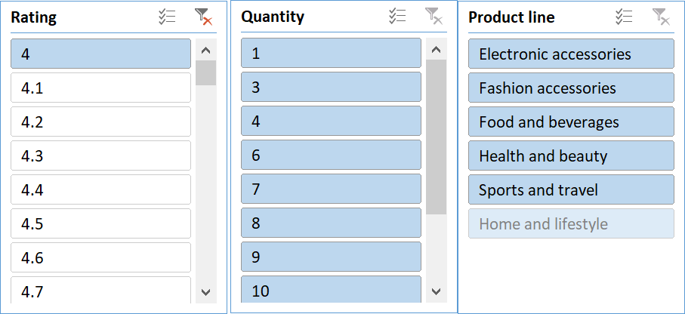

**Q4.** Analyzing units sold and unit price data answer the following sub questions

1. What is the degree of freedom?
2. Co-relation of Unit price and revenue generated
3. What result you can draw from regression of the two data

|  |  |  |  |  |  |  |
| --- | --- | --- | --- | --- | --- | --- |
| SUMMARY OUTPUT |  |  |  |  |  |  |
|  |  |  |  |  |  |  |
| *Regression Statistics* | |  |  |  |  |  |
| Multiple R | 0.010777564 |  |  |  |  |  |
| R Square | 0.000116156 |  |  |  |  |  |
| Adjusted R Square | -0.000885732 |  |  |  |  |  |
| Standard Error | 2.924724997 |  |  |  |  |  |
| Observations | 1000 |  |  |  |  |  |
|  |  |  |  |  |  |  |
| ANOVA |  |  |  |  |  |  |
|  | *df* | *SS* | *MS* | *F* | *Significance F* |  |
| Regression | 1 | 0.9917274 | 0.991727 | 0.115937 | 0.733555221 |  |
| Residual | 998 | 8536.908273 | 8.554016 |  |  |  |
| Total | 999 | 8537.9 |  |  |  |  |
|  |  |  |  |  |  |  |
|  | *Coefficients* | *Standard Error* | *t Stat* | *P-value* | *Lower 95%* | *Upper 95%* |
| Intercept | 5.443794599 | 0.215314544 | 25.28299 | 2.1E-109 | 5.021273429 | 5.86631577 |
| Unit price | 0.001189202 | 0.003492565 | 0.340495 | 0.733555 | -0.005664411 | 0.008042815 |

**Solution:**

1. The degree of freedom of the analyzed data is 1.
2. The Co-relation of Unit Price and Revenue generated turned out to be 0.63392.

The two columns considered in the calculation were Unit Price and the Total.

Function Used: =CORREL

1. From the regression result we can plot the following graph:

**Q5.** What product will you suggest as per the city data analysis to each type of customer

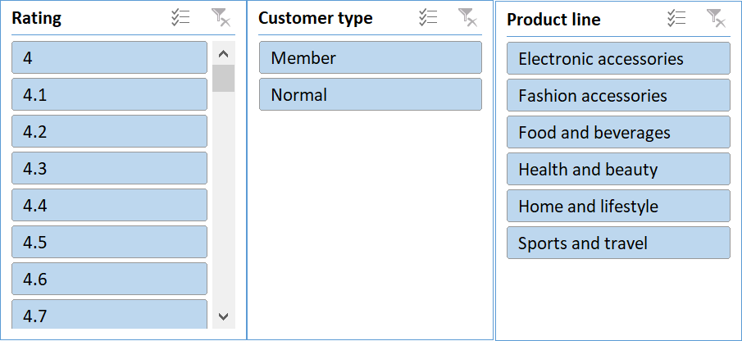

Conclusion and Review:

The comprehensive analysis of supermarket sales dynamics provides valuable insights into consumer behavior, operational trends, and performance metrics. Here's a summary of the findings and reviews:

1. City Performance:

Mandalay emerged as the top-performing city among those with a 5% tax slab. Its superior sales/revenue generation signifies a potentially lucrative market for supermarket businesses.

2. Gender-based Ordering:

Female customers showed a higher propensity to order items from Branch A, while males dominated in Branch C. Branch B saw equal orders from both genders. This gender-specific trend highlights the importance of targeted marketing strategies.

3. Rating and Units Sold:

Further analysis is needed to compare products with the highest and lowest ratings based on units sold. Understanding the correlation between product ratings and sales volume can inform inventory management and marketing decisions.

4. Unit Price and Revenue Relationship:

The regression analysis revealed a weak correlation (R2 = 0.0001) between unit price and quantity sold. This suggests that customers' purchasing decisions may not be significantly influenced by unit price alone, indicating the need for deeper insights into consumer preferences and behavior.

5. Product Recommendations:

Based on city data analysis, Food and Beverages are recommended for member-type customers, while Fashion Accessories are suggested for normal customers. These recommendations align with the observed preferences and purchasing patterns in respective cities.

Reviews:

The report provides a thorough exploration of supermarket sales dynamics, covering various aspects such as city performance, gender-based ordering trends, and product recommendations.

The inclusion of regression analysis enhances the depth of insights, though further interpretation of the results could strengthen the analytical rigor.

Clear visuals, such as graphs and charts, would enhance the presentation of findings and aid in understanding complex relationships.

Overall, the report offers valuable insights for supermarket stakeholders, highlighting areas for strategic focus and improvement in marketing and operational strategies.